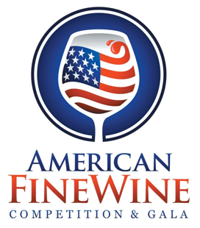
ANNOUNCING THE AMERICAN FINE WINE COMPETITION 2023 RESULTS!

Here is What Happened at the 16th annual, INVITATION-ONLY, AFWC
January 21, 2023, South Florida: The American Fine Wine Competition announced today the results of its prestigious Invitational judging held annually in south Florida. More than 550 wines from 125 wineries vied for top honors at this INVITATION-only event. The Judging - conducted by a 28-member blue ribbon panel of wine industry educators, restaurateurs, retailers, journalists, and top sommeliers from across the country - was held at the Chaplin School of Hospitality & Tourism Management at Florida International University, Biscayne Bay Campus.
Co-founder and President Shari Gherman said, “At AFWC, we look for the very best wines the country has to offer. The wines must be vetted before being personally invited. Our elite acquisition team spends a great deal of time each year tasting thousands of wines from across the U.S. identifying wines they deem to be the best in the country.
Sixteen years of careful scouting and judging means this competition starts where others end. Four-team judging panels evaluate, describe, debate and assign medals and scores. “Our Judges take their time and really care about getting it right” observed Greg Miseyko, Chief Judge and Judging Coordinator. Wines earn Gold, Silver, or Bronze medals. A “Double Gold” is awarded when every judge agrees the wine deserves a Gold Medal. Points from a 100-point scale are also awarded. Miseyko added “We want to direct the public to America’s finest wines, to become the most trusted source of information about finding quality wines. We believe that has been achieved.”
Remember, Price doesn’t always dictate the finest. Quality does.
Congratulations to the BEST OF SHOW WINNERS:

Best of Show Red - Becker Vineyards Barbera, Tallent Vineyard, Texas 2019 96pts $50
Best of Show White - Truchard Roussanne, Carneros, Napa Valley 2021 95pts $30
Sparkling Wine - Domaine Carneros Le Reve Carneros 2015 95pts $125
Sweet Wine- Prager Winery & Port Works, Noble Companion 21 Napa Valley 96pts $80

Attached are the complete results.

They will be posted later tonight at www.AmericanFineWineCompetition.org
For sponsorship opportunities and media requests pleased contact,
Shari Gherman, President
American Fine Wine Competition
Shari@AFWCandGala.com
C: 561.504.0206

